* Purpose : Classwork.
* Date : 24/12/2025
* Author : Vikas Srivastava
* ID : 55984
* Batch ID : 25SUB4505
--------------------------------------------------------------------------------------------------------------------------
- Code : Write a program in C++ to display the message “Hello world!” on the screen using the cout output statement.
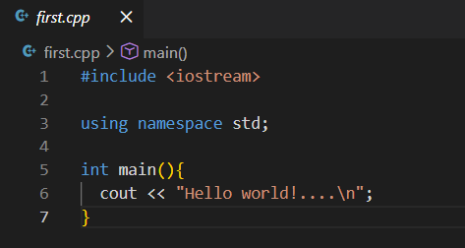
Output :
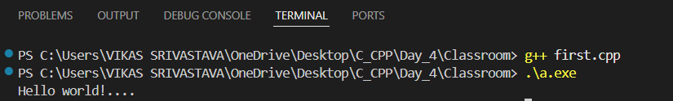
- Code : Write a program to demonstrate pointer type mismatch, where pointers of different data types are assigned to each other, leading to compiler warnings and undefined behavior when dereferencing such pointers.
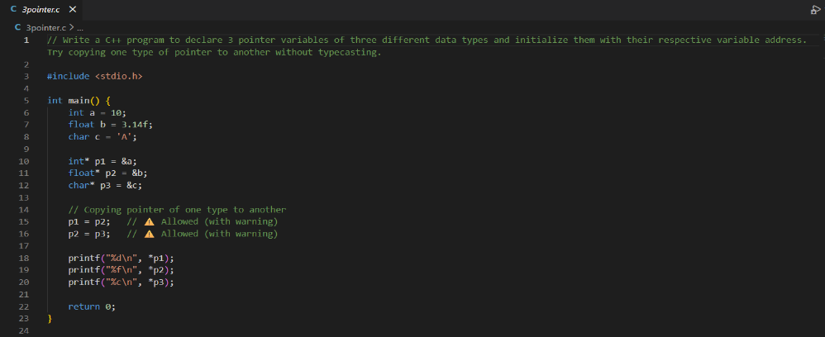
Output :
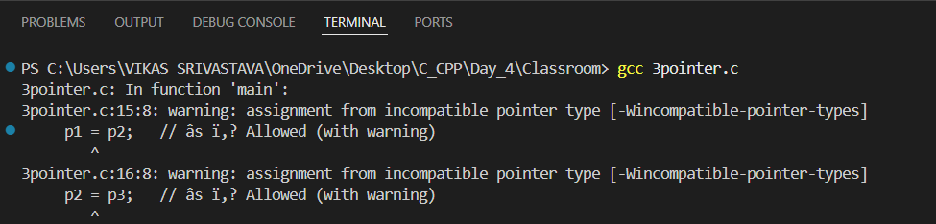
- Code : Write a program to demonstrate strict pointer type safety in C++, where assigning pointers of different data types is not allowed, preventing unsafe memory access and ensuring type correctness at compile time.
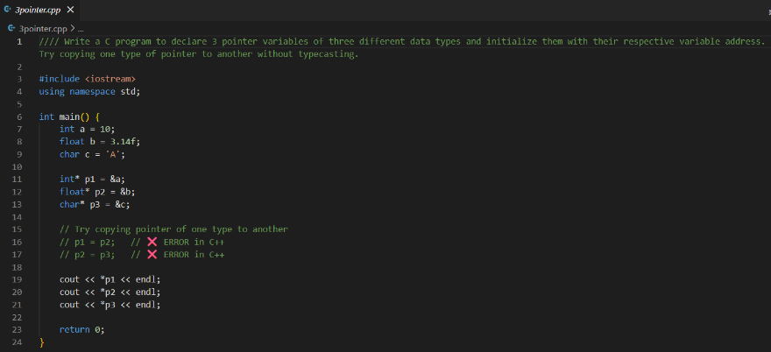
Output :
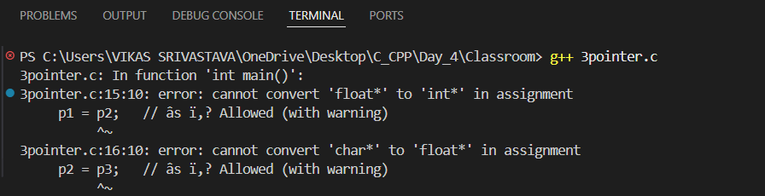
- Code : Write a program to demonstrate the use of the auto keyword in C++, where the compiler automatically deduces the data type of a variable at compile time based on the assigned value.
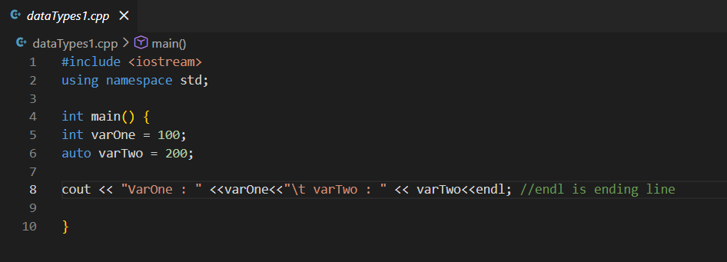
Output :
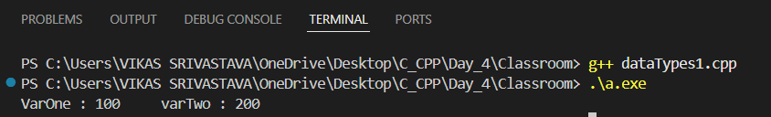
- Code : Write a program to dynamically allocate memory for an integer array using calloc(), initialize the array with consecutive values starting from a user-given number, display the array elements, and finally free the allocated memory.
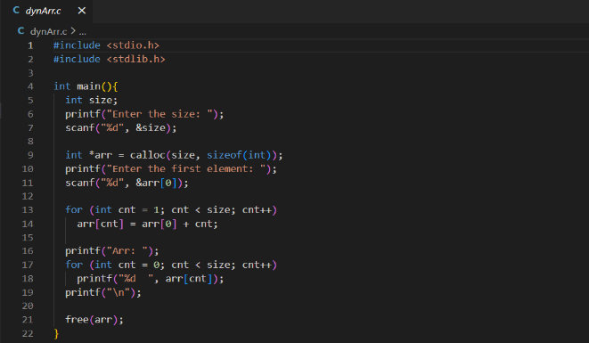
Output :
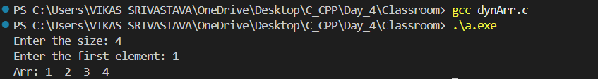
- Code : Write a program to generate random numbers using the rand() function, store them in an array, and display the array elements after initializing the random seed using srand(time(NULL)).
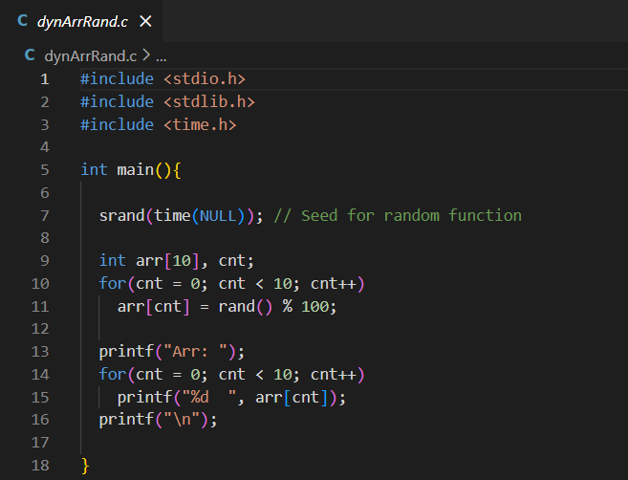
Output :
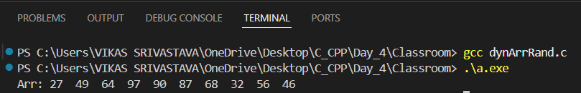
- Code : Write a program to demonstrate dynamic memory allocation using malloc(), store a value in the allocated memory through a pointer, display the memory address and stored value, and finally free the allocated memory.
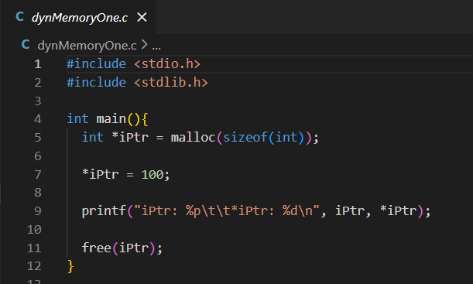
Output :
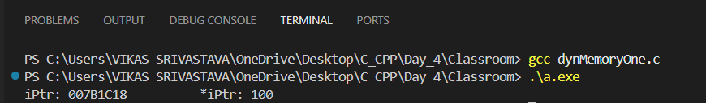

- Code : Write a program to demonstrate dynamic memory allocation in C++ using the new operator to allocate memory for an integer, access the stored value using a pointer, and properly release the memory using the delete operator.
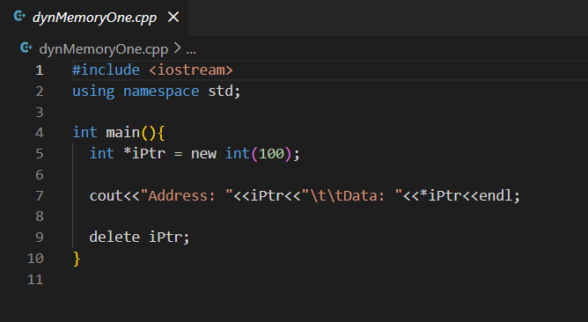
Output :
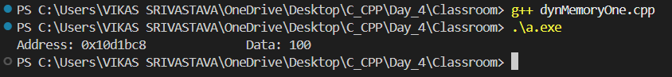

- Code : Write a program to demonstrate the difference between a global variable and a local variable in C++, showing their scope and accessibility within the program.
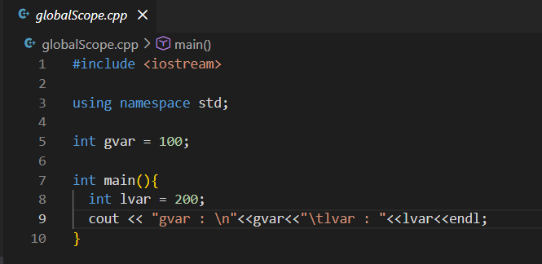
Output :
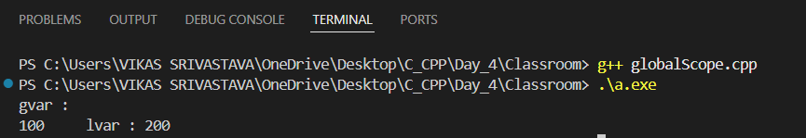

- Code : Write a program to demonstrate the use of multiple namespaces in C++, showing how variables and functions with the same names can coexist and be accessed using the scope resolution operator (::), including global scope and namespace-specific scope.

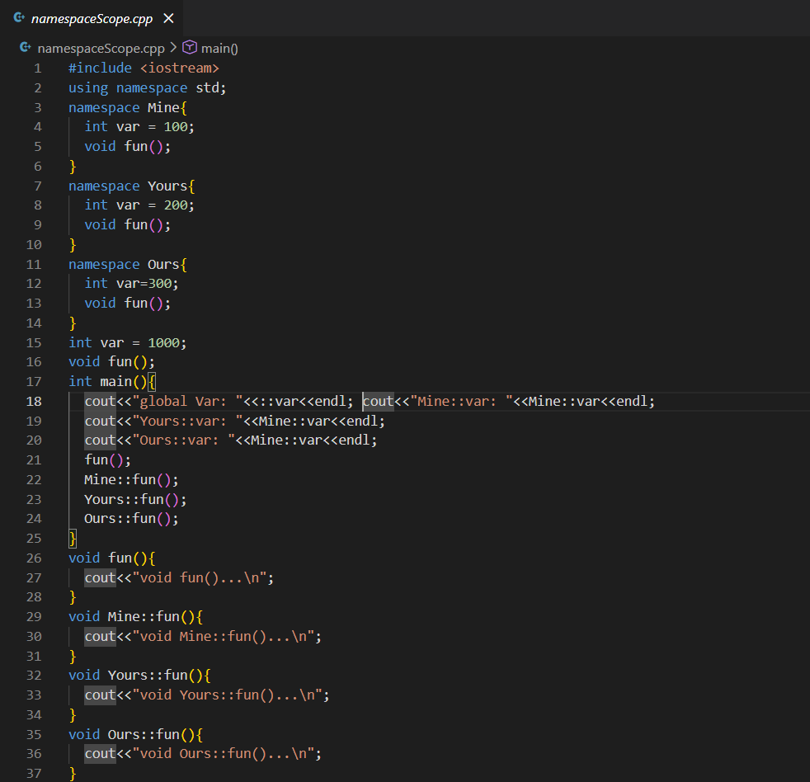
Output :
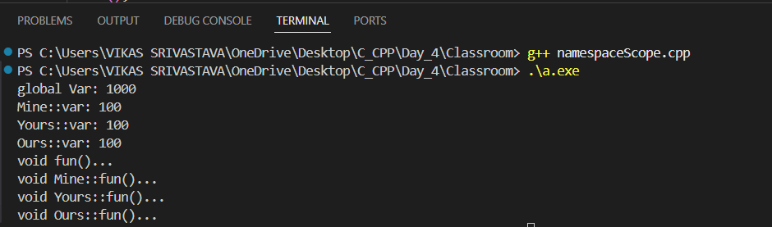

- Code : Write a program to demonstrate how multiple strings can be stored in a two-dimensional character array and printed individually using a loop.
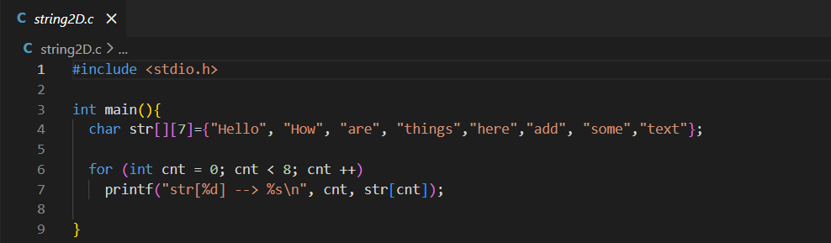
Output :
